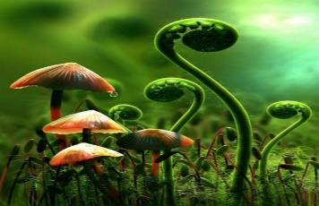
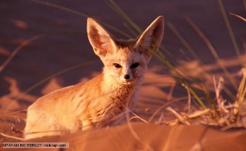
Plant and Animal Adaptations
Biome: ____________________
Plants |  | Animals
Adaptation | Reason | Adaptation | Reason

Plants |  | Animals
Adaptation | Reason | Adaptation | Reason

