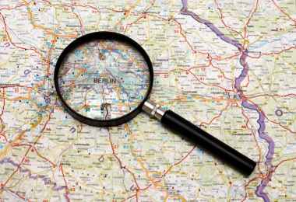
Atlas Scavenger Hunt
In your groups use the atlas to answer the questions. Use the index at the back of the atlas to help you.
1. What is the name of the river that runs through London? ____________
2. Budapest is the capital of which country? ___________
3. Cairo is the capital of which country? ________
4. Algeria, Libya, Sudan, Tanzania, Congo and Ghana are all found on which continent? ________
5. Bangkok is the capital of which country? ____________
6. Which city is the capital of Italy? ___________
7. Sweden, Romania, Slovakia and Ukraine are all countries in which continent? ______________
8. Which city is the capital of Norway? ________
9. What is the name of the two islands in the South Atlantic Ocean off the coast of South America? _________
10. What is the name of the large country in Europe which borders both the Black Sea and the Mediterranean Sea? ___________
11. What is the name given to the volcanic islands in the North Pacific Ocean that are a part of the USA? ______________________
12. What is the name given to the imaginary line around the middle of the world? ___________________
13. Which country covers the most time zones? _____________
14. Atlantic, Pacific, Southern and Indian are all types of what? ________
15. Kiev is the capital city of which country? ________
16. What is the name of the river that runs through 10 countries in Northern Africa including Sudan, Ethiopia and Egypt? The _________
17. The world is made up of many different ecosystems and environments. What is the name given to the common ecosystem of North Africa that is sand and stones with very little vegetation (plants)? _____
18. What is the name given to the highest mountain in the Himalayas? Mt _________
19. Which continent has the highest population (number of people)? ________
20. On a climate graph we show record the average of two measurements of weather. One is temperature, what is the other? _______
21. In addition to the equator there are two additional lines of latitude marked on world maps, what are they called? _____________________ ______________________________________________________
22. What is the name of the coastal town on the border of Kent and East Sussex? _______________
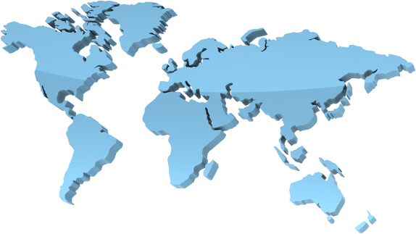
The first letter of each answer creates a phrase. Write each letter out below, can you work out what the phrase is?

