Atmospheric Depressions

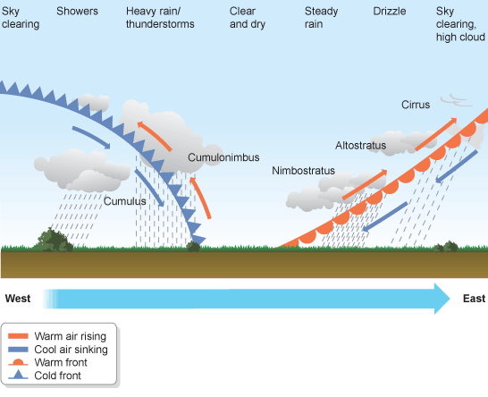

Annotate the diagram marking on the stages from the Slide Share.