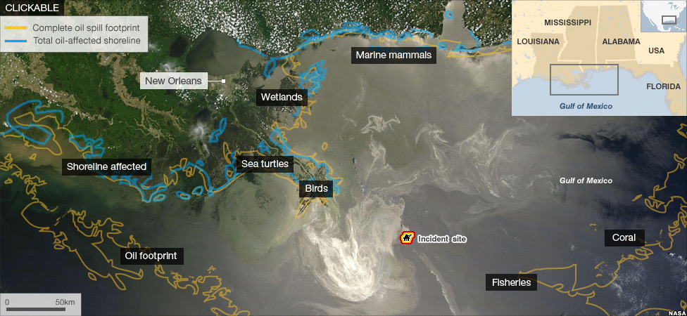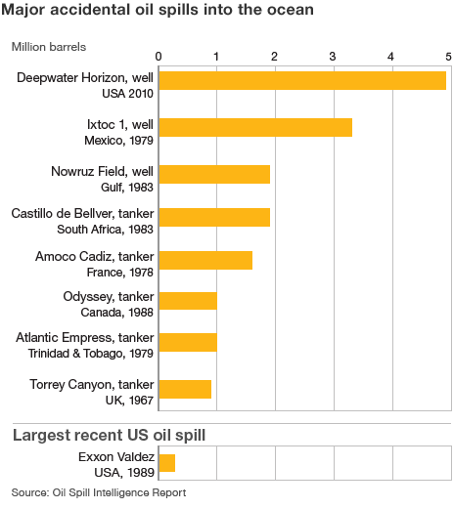

Intro :
- Happened 20 April- 28 june 2010 due to an explosion on the Deepwater Horizon.
- Multiple companies, work teams and circumstances were involved over time.
- The day before the accident, cement was pumped into the drill column of the well to prevent hydrocarbons entering it from the reservoir. The BP investigation says there were "weaknesses in cement design and testing, quality assurance and risk assessment".
- They did not have adequate controls in place to ensure safety.
- It blames the combination of "mechanical failures, human judgements, engineering design, operational implementation and team interfaces".
- The worst environmental disaster the US has faced.
- More than 30 million gallons have spilled into the Gulf of Mexico, affecting more than 110km of Louisiana's coastline.
- More oil is leaking in the Gulf of Mexico than at any other time in US history. It means there is more oil than the Exxon Valdez (in Alaska in 1989)."

Effects and impacts :
- Eleven rig workers died when the Deepwater Horizon exploded and sank.
Environment:
- The oil spill has had a huge impact on communities around the Gulf of Mexico
- Grasses in the wetland regions show damage they become brown with shedding leaves.
- Along the coast, people are struggling daily to nurse oil-soaked birds back to health. They found over 3,000 dead birds.
- In a long term it may change food chains .
- Impact and reductions in productivity of fish, shrimp and other things that live in the water.
- 500 sea turtles and 64 dolphins have also been found dead.
- Invertebrate worms, corals, sea cucumber were killed.
The cost:
- BP's accounts for 2010 put aside $41bn to pay for the spill.
- BP will be fined between $1100 and $4300 for every barrel that was spilled.

Management:
- On the first days, people use undersea robots to slice through the damaged pipe to make a clean cut that can be connected to another pipe, capturing the leaking oil.
- Use of remote sensing equipment, reconnaissance flights and satellite imagery.
- Difficult because they have not been carried out at such great depth as the Deepwater Horizon leak - 5,000 feet (1.5km) below the surface and extremely difficult to clean up especially on the most sensitive ecosystem.
- BP said it would try to ensure the lessons learned from the spill improved deepwater drilling operations.

