Using the link on the GeographerOnline to access different cloud information. Annotate the following points.
Cloud Types
- What do they look like?
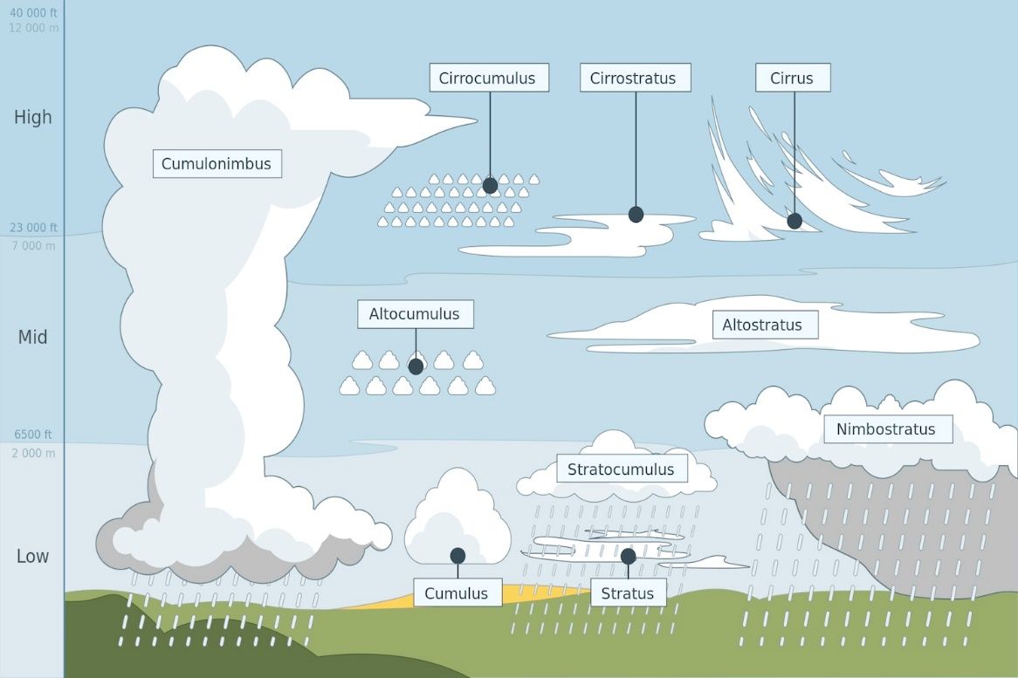
- What are their characteristics?

