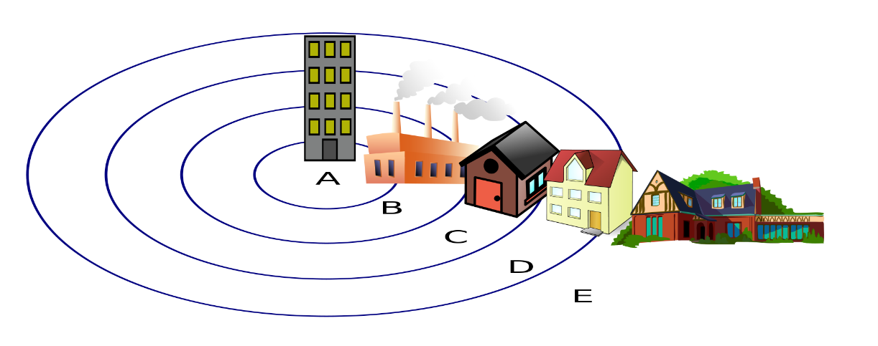
City Transect

Describe each zone.
Zone A:
What type of buildings can you find?
What does it look like (general upkeep, quality of environment)?
Who will you find there and why?

Zone B:
What type of buildings can you find?
What does it look like (general upkeep, quality of environment)?
Who will you find there and why?
Zone C:
What type of buildings can you find?
What does it look like (general upkeep, quality of environment)?
Who will you find there and why?
Zone D:
What type of buildings can you find?
What does it look like (general upkeep, quality of environment)?
Who will you find there and why?
Zone E:
What type of buildings can you find?
What does it look like (general upkeep, quality of environment)?
Who will you find there and why?

