The Earth’s Structrure

- Label the layers of the earth (adding some colour will make it easier to remember).

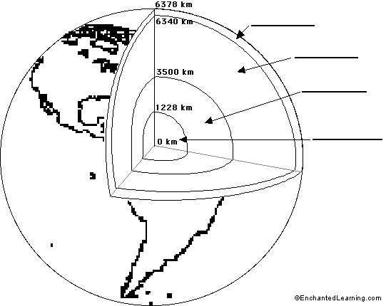

- For each of the above layer describe their characteristics.
Layer | Characteristics

