Changing dietary patterns
Transformation of the proportion of income spent on food
Food expenditure has increased substantially in both countries since the 1970s. However, the proportion of income spent on food, known as the Engel coefficient, is declining, as shown in Figure 1 China's Engel coefficients are lower than India's, while in both countries the coefficients are higher in urban areas compared to rural ones. To look at this in financial terms, in 2005 rural residents in China and India spent US$125 and US$84 per capita per year respectively on food, while the corresponding expenditures of urban residents were US$356 and US$122. This shows that Chinese rural and urban residents have higher food expenditures compared to their Indian counterparts, but the consumption gap between urban and rural dwellers is wider in China.
Changing food baskets
Changes in food basket composition are a significant component of food pattern trends in China and India. The share of cereals, for example, has shown a marked decrease: in rural India, 54.4% of food expenditure went on cereals in 1970/71, reducing to 32.7% in 2004/05 (the corresponding figures for urban India are 35.6% and 23.7% respectively). While the data do not allow an exact comparison, a similar trend nevertheless emerges in China: in 1978, the share of cereals in food expenditure in China was 65% for rural and 22% for urban consumers, by 2009 the share for urban consumers had declined to 8% (rural data not available).
In contrast, both countries have experienced a rise in the consumption of animal products, which can once again be seen by analysing trends in food basket composition: rural India's expenditure on animal products has risen from 15.5% in 1970/71 to 21.4% in 2004/5; while this figure has risen from 20.3% to 25% for urban residents, now exceeding the share of cereals in their food baskets (see Figure 2). Similar data are unavailable for China but it is highly likely that a parallel change has occurred.
Due to a unique prevalence of lacto vegetarianism, India's consumption of animal products is dominated by milk, while meat consumption is low. The reverse is true in China, with pork consumption being particularly significant. However, these historical preferences are starting to change as diets diversify. For example, chicken, goat and - to a lesser extent - beef consumption have risen considerably in India, and in urban China the consumption of fish and dairy products is rapidly increasing.
There is much regional variation in animal product consumption within India and China, caused by many factors including differences in income, food habits and product availability. In China for example, the uneven distribution of certain ethnic minority groups across the country is a major reason for regional variation in the consumption of products such as dairy foods, beef and mutton.

The drivers of dietary change
Many factors are driving dietary change in India and China; of these, rising income is the most important. As observed throughout the world, as incomes rise, consumers reduce their consumption of foods of plant origin, switching to more expensive foods, particularly animal products.
Urbanisation is another important influence since urban residents tend to consume less cereals and more animal products than rural populations. Furthermore, this factor is becoming increasingly significant: China's urbanisation level has increased from 20% in 1980 to 50% in 2010 and during the same period India's urbanisation has increased from 23% to 30%.
The combination of increased income and urbanisation leads to major lifestyle changes, which are themselves another cause of dietary change. For example, eating out, taking holidays and convenience foods are becoming increasingly popular in China; while in India a young and more affluent workforce is going out to restaurants and opting for convenience foods more often.
Greater opportunities for cultural exchange are also a factor for change, with Indian and Chinese citizens becoming increasingly influenced by worldwide cultures, stimulating interests in untraditional foods - beef for example in India, or dairy products in China, the consumption of which is increasing in both cases.
A final influence to mention is improvements in food production and marketing, such as the introduction of modern cold chain transportation and storage facilities. Such developments are improving food availability throughout these countries. In addition, supermarkets, which are emerging particularly rapidly in China, are also having a key effect.

Future outlook
The drivers of dietary change will continue to exert their influence for the foreseeable future. While rural consumption of animal products in both countries will lag far behind their urban counterparts for some time, it is likely that rural trends will emulate urban ones to some extent. It can also be anticipated that marketing improvements will make different food products more widely available throughout China and India, although regional differences will remain. In addition to dietary changes, consumers in both countries will increasingly demand safer and higher quality products.
Research conducted by the authors, along with the findings of other studies (e.g. Bhalla, Hazell and Kerr, 1999; Zhou and Tian, 2005) suggest that India and China should be able to produce sufficient amounts of cereals to meet domestic demand in the near future; however, their ability to produce enough animal products is questionable. Both governments have emphasised the importance of self-sufficiency in cereal supply. The main objective of India's 2007 National Food Security Mission (NSFM) is "to increase production and productivity of wheat, rice and pulses on a sustainable basis so as to ensure food security of the country" (Government of India, 2007). In 2008, the Chinese government published its 'Outlines of medium- and long-term national grain security plan (2008-2020)', in which the government set a target to achieve a self-sufficiency rate of no lower than 95% for its major staple cereal supply (self-sufficient for rice and wheat, largely self-sufficient for maize) (Government of China, 2008).
Both governments have implemented policies to boost cereal production. In India, the NFSM has pledged to enhance the production of rice, wheat and pulses by a total of 20 million tonnes by the end of the Eleventh Five-Year Plan, i.e. 2012. In China, due to strengthened government support, grain production has increased successively over the past seven years, reaching 546 million tonnes in 2010.
It thus appears that, although facing major challenges due to urbanisation, industrialisation, resource depletion and environmental degradation, India and China both intend to meet their rising demands for cereals largely through domestic production for the near future. Long-term cereal self-sufficiency for India however looks more problematic due to declining resources (limited land and increasing water scarcity) together with an increasing population (Gandhi, Zhou and Mullen, 2004). China, in contrast, is in a stronger position to remain self-sufficient for cereals in the long term, particularly because its population will start to decline by around 2035. Therefore, China is unlikely to have a major direct effect on global markets, particularly for rice and wheat.
In contrast, both countries will have major difficulties in producing enough animal products to meet growing domestic needs. In India, the animal industry would need an unprecedented boost to avoid large gaps between supply and demand that are likely to emerge for many types of meat (except chicken) as well as eggs and dairy products (Gandhi and Zhou, 2010). For China, according to Wang (2010), a shortage of meat and eggs may not emerge until 2025 or 2030, triggering the need to import. For dairy products, however, China has already experienced shortages and resorted to importation; a phenomenon that is likely to continue.
Wang's projection is based on the assumption that China has sufficient feedstuffs for domestic animal production. However, this may not be the case. In 2010, China imported 55 million tonnes of soybean (85% of which was for animal feed) and 1.5 million tonnes of maize. Three million tonnes of corn meal were also imported in 2010. In future, it remains to be seen whether China will need to import animal feeds, animal products or livestock and to what extent. However, whatever action China and India take, they are sure to have a major impact on the world food situation.

The benefits of urban living
In India, as in China, the share of income allocated to food expenditure has steadily declined, reflecting the overall increase in the average incomes of the two populations. However, the proportion of food expenditure remains higher for rural citizens, who have lower incomes, than for urban dwellers. In India, this gap between the two populations is increasing.
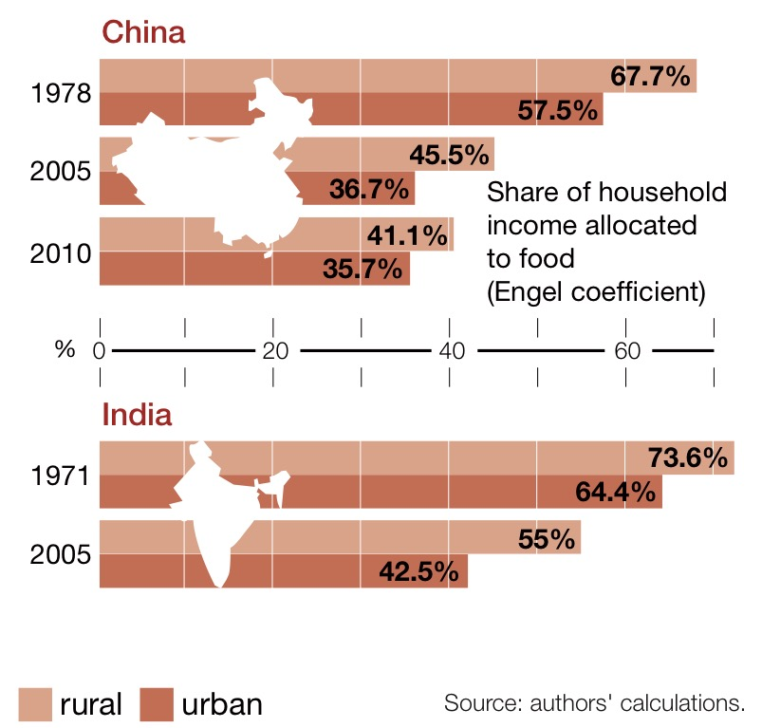
Show Media

Less grain, more protein
The evolution of the Indian food basket is representative of many emerging countries: an increase in living standards results in lower cereal consumption, even in rural areas, and an increased consumption of animal protein.
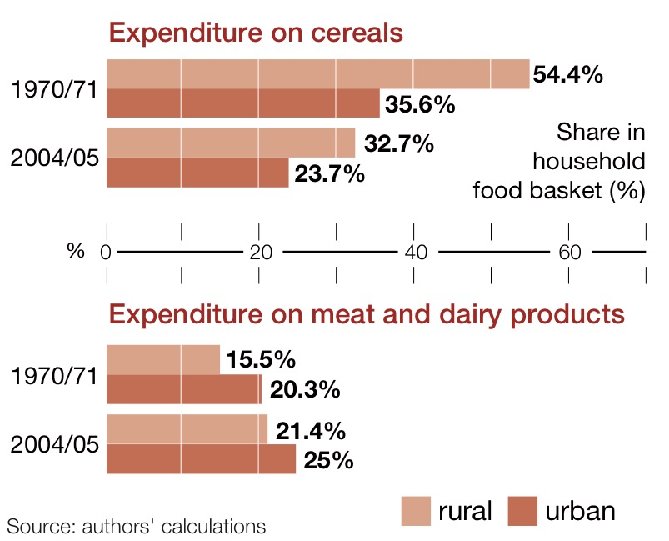

Source: A Planet For Life
http://regardssurlaterre.com/en/changing-patterns-food-consumption-india-and-china

