Our Earth’s Atmosphere

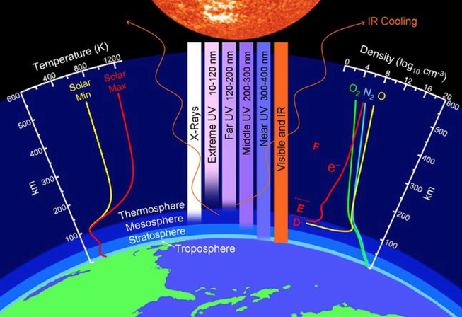

Troposphere | Stratosphere | Mesosphere | Thermosphere

