Population Pyramids
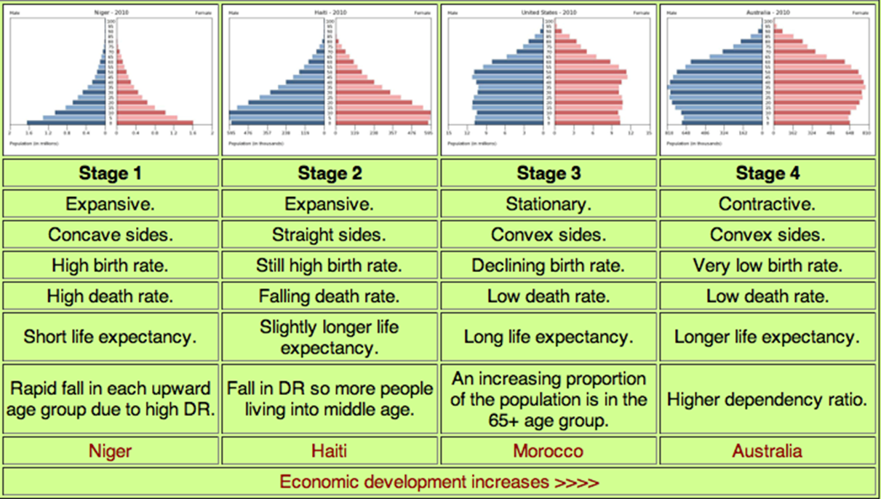
- Using the YouTube and the above image explain. What are population pyramids and what do they show?
_____________________________________________________________________________________________________________________________________________________________________________________________________________________________________________________________________________________________________________________________________________________________________________________________________________________________________________________________________________________________________________________________________________________________________

- Describe the population pyramid in Stage 1.
________________________________________________________________________________________________________________________________________________________________________________________________________________________________________________________________________________________________________________________________________________________________________________________________

