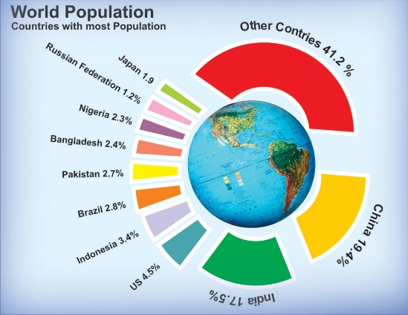
World population

Using the graphs and images on the website, describe how the world population has changed over the years.
Change in number:
________________________________________________________________________________________________________________________________________________________________________________________________________________________________________________________________________________________________________________________________________________________________________________________________________________________________________________________________________________________________________________________________________________________

Change in distribution
___________________________________________________________________________________________________________________________________________________________________________________________________________________________________________________________________________________________________________________________________________________________________________________________________________________________________________________________________________________________________________________________________________________________________________________________________________________________
