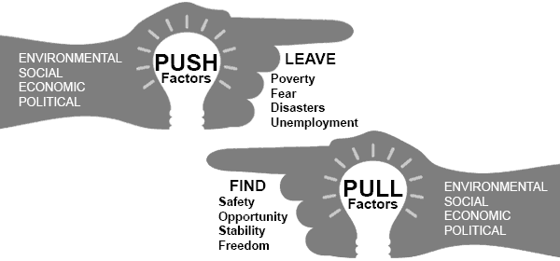

Definition of Push and Pull factors of Urbanization
- Push factors are the reasons why people left rural locations in the countryside, such as poverty and unemployment
- Pull factors are the reasons why people moved to urban locations in towns and cities such as new technology, greater opportunities, better facilities and increased wealth
Definition: Urbanization is the process of changing from life in a rural area in the countryside to an urban area in a town or city.
Industrialization and New Technology
The world saw a rapid growth in Urbanization during the 1800's due the inventions and new technologies of the Industrial Revolution in relation to textiles, iron & steam and then innovations in steel, oil and electricity. These developments led to increased agricultural efficiency requiring less labor in rural areas, better transportation systems, communications and the mechanization of industries that resulted in the emergence of factories that required more labor in the cities and towns.
Examples of Urbanization Chart
The following chart provides facts and information about some specific examples of Push and Pull factors of Urbanization - leaving a rural life in farming and the countryside to move to the cities and towns and an urban life.
Examples of Push and Pull factors of Urbanization
Examples of Push Factors of Urbanization - Leaving the countryside | Examples of Pull Factors of Urbanization - moving to cities
Agriculture: Increased agricultural efficiency that displaced farm workers. Examples of this were due to inventions such as the Cotton Gin, Cotton Spinning Machinery, the McCormick Reaper and the Grain Elevators that featured in the industrialization of America. | Agricultural workers moved to the towns and cities to work in factories that required unskilled labor.
Transportation: Developments in transportation systems such as new roads, railroads and canals in the 1800's saw the introduction of steam trains and steamboats. New technology and inventions then gave way to the automobile and airplanes. This made it easier for people to travel vast distances. | The ease of travel and the new transportation systems enabled people to move from a rural location to an urban area quickly and cheaply.
New Inventions: New inventions required lower skill levels and cheap ready-made goods. Skilled workers who traditionally worked in rural areas, such as blacksmiths and carpenters, were displaced and needed new employment. | Opportunities for employment in new emerging industries and factories.
Infrastructure: As people moved from rural areas and population levels dropped less money was spent on roads, bridges, construction, schools and hospitals | The infrastructure of towns and cities increased as new building and convenient facilities were made available to the increasing population.
Cultural Factor: There was less money to spend on cultural facilities such as museums, libraries and art galleries. | People move to cities to enjoy new recreational resources and cultural facilities
Goods and Services: Goods and services available to rural communities are limited | City and town living provides easy access to goods and services that ensure convenience and variety
Excitement and adventure: Traditional rural communities were considered old fashioned and boring | People moved to towns for adventure and the bright lights of the city
Education: Less money is spent on educational resources in rural areas | Educational facilities in towns and cities offer a range of choice and access to education for all ages and easy access to colleges and universities providing better education
Health and Medical Care: Fewer doctors and medical facilities in rural areas | Good health care and hospitals in easy reach of city dwellers
Freedom: Activities can be restricted in rural areas due to resistance to change and adherence to traditional values | Religious and political activities can be carried out more safely and with greater acceptance in larger towns and cities.
Opportunities: Limited new opportunities in rural areas. | Big companies offering new employment opportunities, career advancement and high wages are generally based in major towns and cities
Lack of investment: Limited amounts of government money is spent on rural areas | Government money is made available to highly populous areas
Examples of Push Factors of Urbanization - Leaving the countryside | Examples of Pull Factors of Urbanization - moving to cities

