Alina Tomova

Case study: Senkaku/Diaoyu dispute between China and Japan.

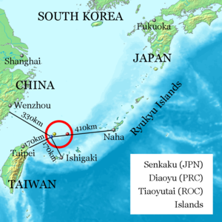
Intro:
- Since 1971 till current time.
- 5 inhabited islands + 3 barren rocks
- Area range: 0.0008-4.32 km²
- In the East Asia Sea
- 170 km Northeast of Taiwan;
- 410 km Southwest of Japan;
- 330 km Ester of China;
On the Chinese side of the Okinawa shelf;

Reasons:
- Lose to key shipping lanes
- Rich fishing grounds
- Oil deposits (petroleum)
- Natural gas

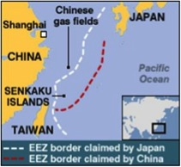
Claims:
- All of the land on the country shelf out to the Okinawa Trough, which is 200 nautical miles

! Problem - boundaries overlap:
The distance between two countries is less than 400 nautical miles.

Results:
- Agreement (1997) provided Provisional Measures Zone in the East China Sea, where China and Japan would cooperate and have access to fishery resources.
- Japan purchased 3 of the disputed islands.
- The problem with the islands is not sorted out.
The map shows the different EEZs claimed by Japan and China, 2010.

- The tension in China increases.

* Taiwan also claimed for the territory however is has a weaker voice in the debate since it is depended on fishing in those waters. The only solution is to bargain with the countries to continue its fishing practices.

Sources:
http://blogs.scientificamerican.com/expeditions/2013/06/07/the-senkakudiaoyu-island-dispute-in-the-east-china-sea/
http://www.historytoday.com/joyman-lee/senkakudiaoyu-islands-conflict
http://www-ibru.dur.ac.uk/resources/docs/senkaku.html

