Alina Tomova

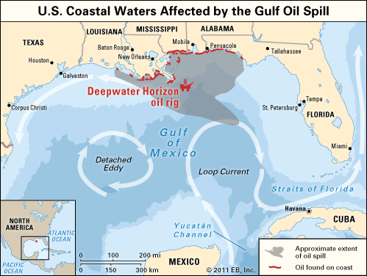
Case study: Deepwater Horizon oil spill.

Intro:
- The largest accidental marine oil spill;

April-September 2010;
- In the gulf of Mexico, near Mississippi River Delta, United States;

Reason:

Deepwater Horizon explosion

Result:
- 4.9 million barrels of petroleum spilled
- Area of spilled oil - 6,500 to 180,000 km²
- A sea-floor oil gusher flowed for 87 days
- 11 men killed and 17 injured.
- 16000 total miles of coastline have been affected, including the coasts of Texas, Louisiana, Mississippi, Alabama and Florida.
- 40000 pound tar mat near Louisiana, approximately 1/3 of Louisiana coast polluted
- Extensive damage to marine and wildlife habitats, the Gulf's fishing, tourism industries
- 80-square-mile "kill zone" surrounding the blown well
- Over 8000 animals died after 6 months

Solutions:

It was stopped by capping the gushing wellhead

Skimmer ships, floating containment booms, anchored barriers, sand-filled barricades along shorelines

1.84 million US gallons of Corexit oil dispersants to protect hundreds of miles of the territories from the spreading oil.

Over 30000 people responded to the spill, working to collect oil, clean up beaches, take care of animals etc.
- 20 billion dollars spill response fund by the US government.
- All the payments and settlements cost the BP company about $42.2 billion

Source:

http://en.wikipedia.org/wiki/Deepwater_Horizon_explosion

