**Case study:** **OLD Dependents – JAPAN**

# http://www.operationworld.org/files/ow/maps/lgmap/japa-MMAP-md.pngWHAT:

# Large Dependency Ratio (2009)

# Total dependency ratio: 75.0

# High Old Dependency Ratio (2009)

# Elderly-dependency ratio: 51.8

# Young- dependency ratio: 23.2

**CAUSES:**

# High life expectancy

# 🡪+2 million people aged over 80

# 🡪 1 in 5 people aged over 60

* Good diet
* Good medical care
* Good hygiene and healthcare

Japan's 2010 Population Pyramid

* Low birth rate
* 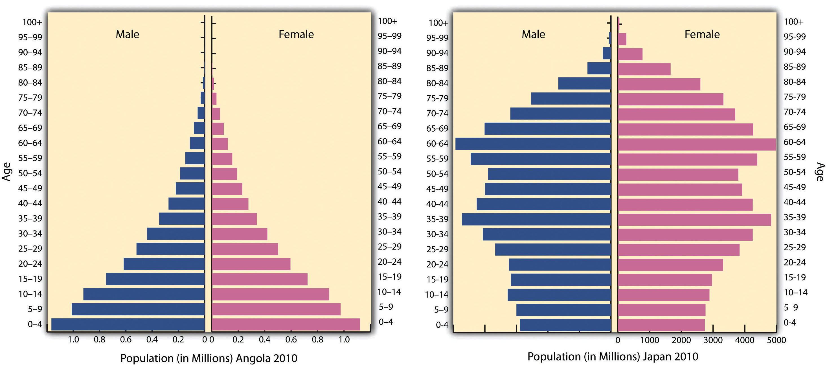Emancipation of women
* Cost of children
* Emigration of economically actives

**EFFECTS**

Disadvantages

* Trade deficit
* Migration of Japanese industries overseas
* Depletion
* Labor force may drop by 9.5 million by 2030
* Pressure on Health Service
* Inadequate nursing facilities
* Cost of providing healthcare and care homes
* Falling demand for schools and teachers
* Pressure on nation’s economy
* Cost of funding pensions
* Reduced taxation income for the government

Advantages

* Expertise and experience; wide skill base
* No maternity or paternity leave
* More loyal, reliable (no other constraints)
* Willing to work part-time or flexi-time
* “Granny culture” enables parents to work while they look after their children
* “Grey economy” Viewed as an important market (healthcare providers, holiday companies)

**SOLUTIONS**

* Pro-natalist policies
* Increase immigration of economically active or young dependents
* Increase retirement age
* Private pensions and healthcare
* Increased taxes on economically active

**Case Study: YOUNG Dependents – UGANDA**

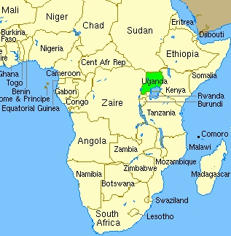**WHAT**

* Large Dependency Ratio (2010)
* 50% of population under 15 years old
* 3% of population over 65
* Total dependency ratio: 103.8
* High Young Dependency Ratio (2010)

- Young Dependency Ratio: 98.7

**CAUSES**

* Low life expectancy: around 52 years
* High birth and fertility rates
* 48 babies born for every 1000, every year
* Average of 7 children per woman
* 2025: population will double to 56 million

**EFFECTS**

Advantages

* Large potential workforce (Shortage of workers BUT in the short-term)
* Lower medical costs
* Attractive to new investments
* Source of new innovation and ideas
* Large potential market for selected goods
* Developments of services such as schools, crèches

Disadvantages

* Pressure on health service – 6000 women/year die in childbirth

- Cost of supporting schools and clinics (midwives)

* Need to provide sufficient food, housing and water to a growing population, e.g. Kampala
* High rates of unemployment
* Large numbers living in poor quality housing, e.g. in shanty towns
* High rates of population growth
* High crime rates
* Shortage of workers: in 2003 unemployment was 3.2%
* Increased dependency ratio
* Spending diverted from defense, transport



**SOLUTIONS**

* Anti-natalist policy (China One child)
* Immigration economically active
* Education (privatized)
* Removal of child benefits
* Quotas (immigration restrictions)

Uganda's

Population Pyramid 2005