CASE STUDY - ENVIRONMENTAL DISASTER

The Exxon Valdez Oil Spill
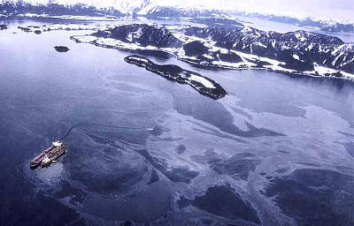
When?
23rd of March 1989
What?
Oil tanker EXXON Valdez ran into Bligh Reef = 260,000 to 750,000 barrels of crude oil was spilled in Prince William Sounds (Alaska) = considered to be one of the most devastating human caused environmental disasters
Effects?
Short term:
- deaths of 250,000 seabirds + 2,800 sea otters + 300 harbour seals+ 247 Bald Eagles + 22 Orcas+ 1000 harlequin ducks many salmon and herring in the following days
- 1,300 miles of coastline hit by the oil spill

Long term:
- chronic injuries for animals= still not fully recovered
- Many fish populations were harmed during the spill + south-western part of Prince William Sound lost 28% of potential stock of wild pink salmon=over $300 million economic loss to more than 32000 people who depended on commercial fishing
- Salmon eggs exposed to the oil= increased salmon mortality for 4 years after the spill= contaminated food chain= larger marine mammals and ducks suffered illnesses
- Following year, tourism spending= - 8% in south central Alaska and -35% in southwest Alaska
- loss of 9,400 visitors
- Loss of $5.5 million in state spending.
- 12 years after the spill, oil could still be found on randomly selected beaches on the coast

Solutions?
- The clean-up required about 10,000 workers+ 1,000 boats + 100 airplanes / helicopters.
- Four deaths were directly associated with clean-up efforts.

