Granite
- Granite is made up of three minerals: quartz, feldspar and mica.
- It is a hard, crystalline rock, which is very resistant to erosion.
- It is an intrusive igneous rock.
- The main processes that affect it are freeze-thaw and hydrolysis.
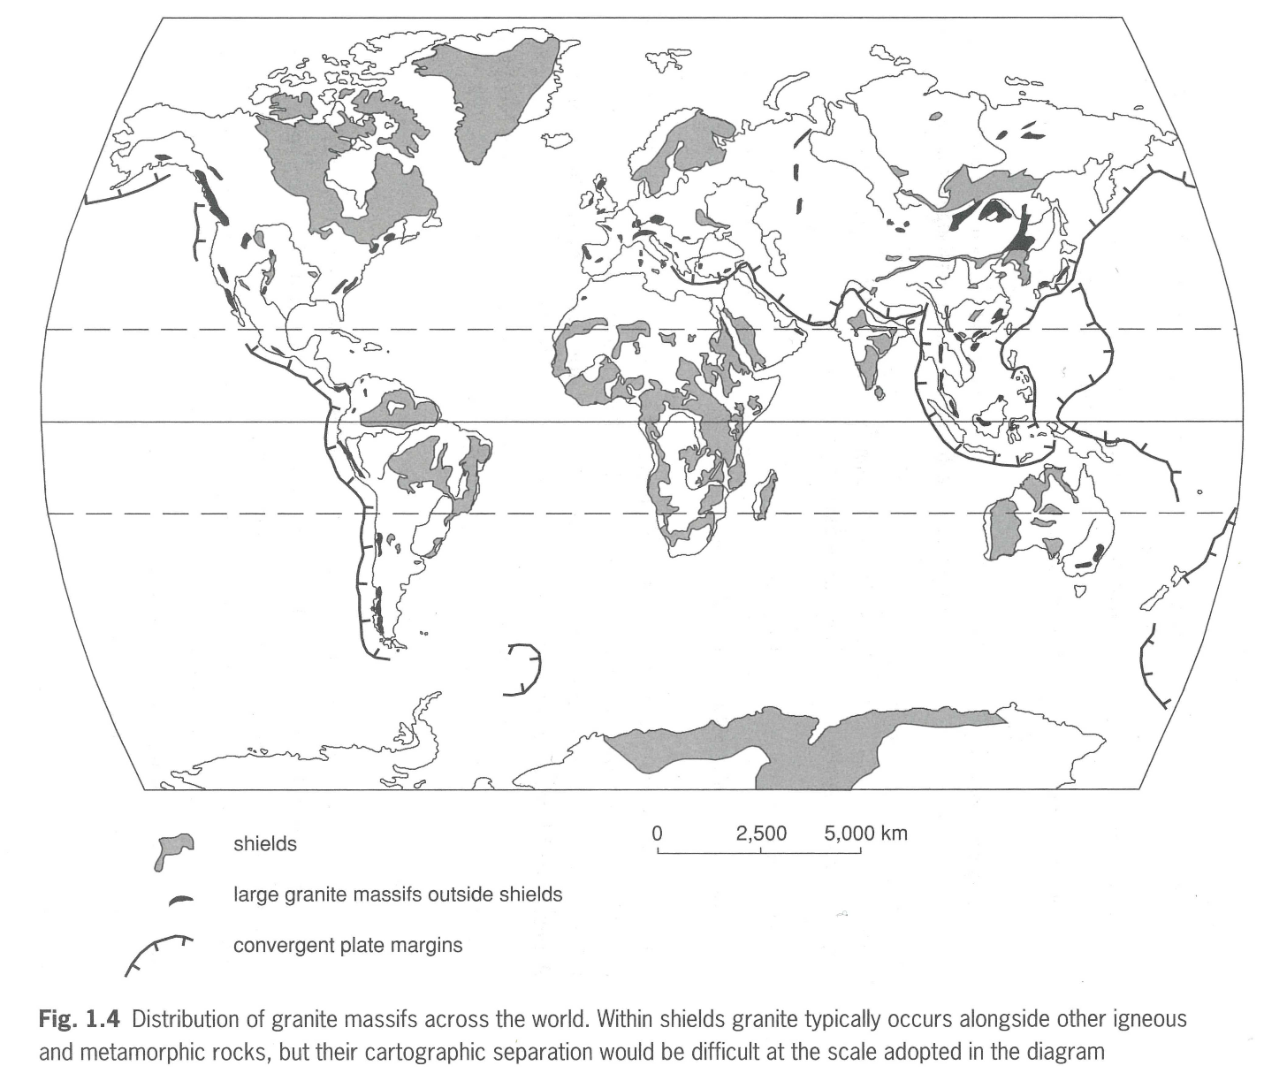
Describe the distribution of Granite in the world
__________________________________________________________________________________________________________________________________________________________________________________________________________________________________________________________________________________________________________________________________________________________________________________________________________________

Using the YouTube create a spider diagram of all the facts you can identify about granite.
Granite

