How has the coastal management strategy at ‘La Gravette’ affected the beach profile and sediment composition?

Managed Beach
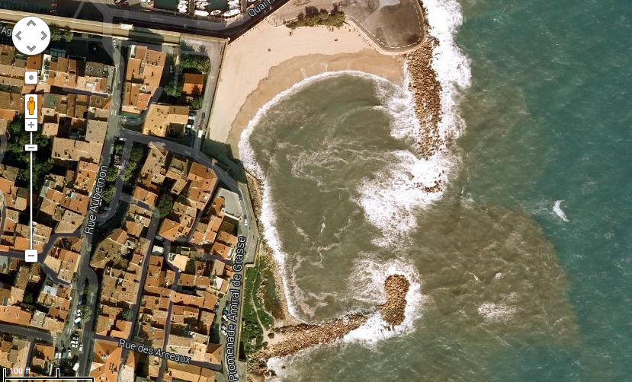
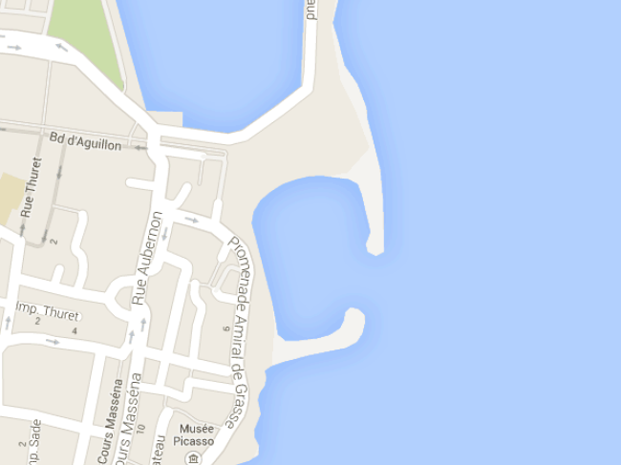
Unmanaged beach
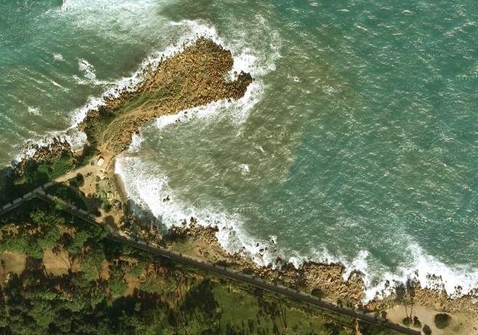
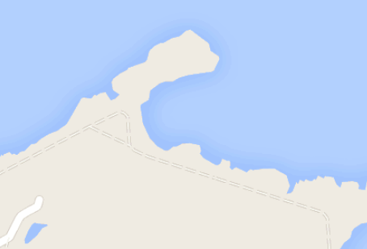

Beach Profile
Location: La Gravette (Managed beach)
Measurement | Site A | Site B | Site C
1
2
3
4
5
6
7
8
9
10
11
12
13
14
15

Measurements are taken in degrees°
You will need to measure the width of the beach first and then decide how many meters you will divide up each measurement into. [_____________]
Observations: (as you are taking the measurements you need to make some observations about the morphology of the beach, are there any large anomalies, why do you think they have occurred?)
________________________________________________________________________________________________________________________________________________________________________________________________________________
Location: La Joliette (Unmanaged beach)
Measurement | Site A | Site B | Site C
1
2
3
4
5
6
7
8
9
10
11
12
13
14
15

Measurements are taken in degrees°
You will need to measure the width of the beach first and then decide how many meters you will divide up each measurement into. [_____________]
Observations: (as you are taking the measurements you need to make some observations about the morphology of the beach, are there any large anomalies, why do you think they have occurred?)
____________________________________________________________________________________________________________________________________________________________________________________________________________________________________________________________________

Wave Count
Location: La Gravette (Managed beach)
1min | Site A | Site B | Site C
1st
2nd
3rd
4th
5th

Wave Count
Location: La Joliette (Unmanaged beach)
1min | Site A | Site B | Site C
1st
2nd
3rd
4th
5th

Wave Height
Location: La Gravette (Managed beach)
 | Site A | Site B | Site C
1st
2nd
3rd
4th
5th

Using the 1m ruler (if wet dry it) between waves place ruler into water until it is touching the sand (take note of the measurement) then when the next wave comes in and washes up the ruler take note of the wetted part of the ruler. The difference between the original depth and the wetted section after the wave has passed is the wave height.

Observations (take note of anything that might affect the wave height)
____________________________________________________________________________________________________________________________________________________________________________________

Wave Height
Location: La Joliette (Unmanaged beach)
 | Site A | Site B | Site C
1st
2nd
3rd
4th
5th

Using the 1m ruler (if wet dry it) between waves place ruler into water until it is touching the sand (take note of the measurement) then when the next wave comes in and washes up the ruler take note of the wetted part of the ruler. The difference between the original depth and the wetted section after the wave has passed is the wave height.

Observations (take note of anything that might affect the wave height)
____________________________________________________________________________________________________________________________________________________________________________________
Sediment
To compare sediment type you need to take photographic evidence of the sediment on the beaches. You will need to show how one is a shingle and the other sand. You will take 3 Photographs in the center location.
Photos Tick once completed:
 | Managed Beach | Un-managed Beach
Lower
Mid
Upper

Beach width
La Gravette (Managed beach)
 | Site A | Site B | Site C
Width (m)

Location: La Joliette (Unmanaged beach)
 | Site A | Site B | Site C
Width (m)

Long Shore Drift
Location: La Gravette (Managed beach)
Round
5min | Site A |  | Site B |  | Site C
 | Distance | Direction | Distance | Direction | Distance | Direction
1st
2nd
3rd

Cylindrical
5min | Site A |  | Site B |  | Site C
 | Distance | Direction | Distance | Direction | Distance | Direction
1st
2nd
3rd

Make a record of direction of movement eg compass bearing
Measurements need to be recorded in units of distance (chose the most appropriate)
However!!
Use the same units for all sites

Observations: (as you are taking the measurements you need to make some observations about factors that might affect the readings eg wind, waves and possible outside interference such as a boat going past)

______________________________________________________________________________________________________________________________________________________________________________
Long Shore Drift
Location: La Joliette (Unmanaged beach)
Round
5min | Site A |  | Site B |  | Site C
 | Distance | Direction | Distance | Direction | Distance | Direction
1st
2nd
3rd

Cylindrical
5min | Site A |  | Site B |  | Site C
 | Distance | Direction | Distance | Direction | Distance | Direction
1st
2nd
3rd

Make a record of direction of movement eg compass bearing
Measurements need to be recorded in units of distance (chose the most appropriate)
However!!
Use the same units for all sites

Observations: (as you are taking the measurements you need to make some observations about factors that might affect the readings eg wind, waves and possible outside interference such as a boat going past)

______________________________________________________________________________________________________________________________________________________________________________

