GCSE Geography

Primary Data Collection Pack

*‘Investigate the environmental impacts of tourism on Mutianyu Great Wall, Beijing.’*

September 12th 2017

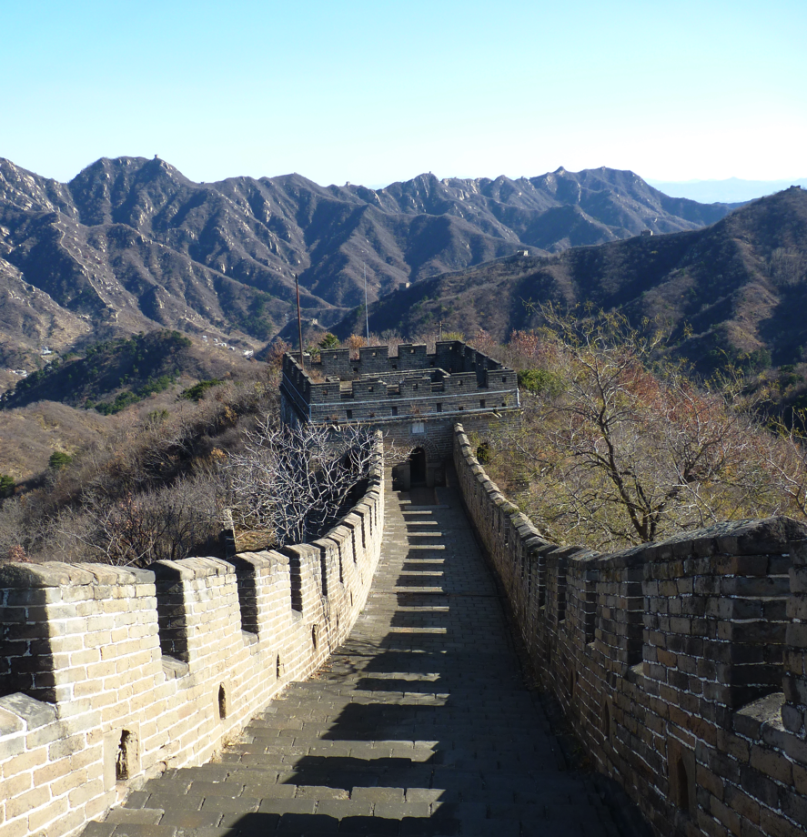

Student Name: ________________

Don’t forget to take photographs throughout the day, especially of you collecting the data as this can go in your methodology table.

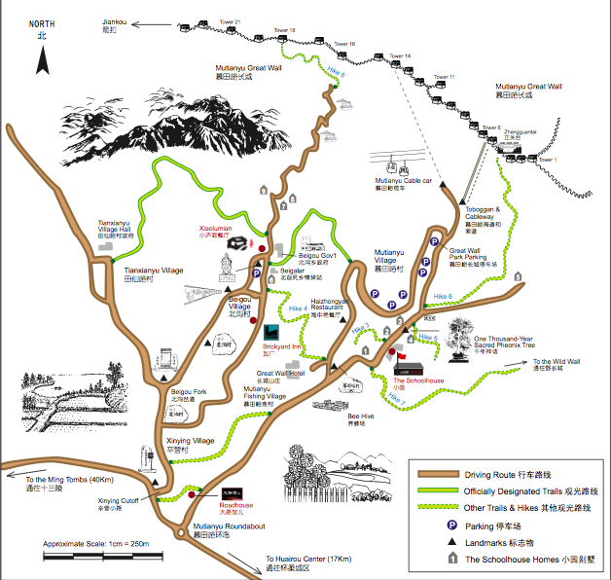

1 = Visitor Centre Carpark

2 = Main entrance to the Great wall

3 = On the Great wall

Note: When filling in the EQI the lowest score is -2, 0 is an average score and 2 is the highest score.

Environmental Quality Survey Site 1

|  |  |  |  |
| --- | --- | --- | --- |
| Criteria | Worst EQ: | Scale | Best EQ: |
| Building Condition: | Poor Conditions: Lack of maintenance; peeling paint; some damage e.g footpath erosion; not cleaned; temporary structure. | **-2 -1 0 1 2** | Excellent condition e.g. no peeling paint, no cracking, evidence of cleaning; no visible signs of damage; permanent structure. |
| Green Space: | Dirt; concrete; no plants; unplanned; weeds; no management. | **-2 -1 0 1 2** | Large areas of green space; variation of plants; health of plants; evidence of gardening (mowing etc.); designed/planned. |
| Rubbish/Litter: | No bins; lots of litter evident on streets | **-2 -1 0 1 2** | Multiple well placed bins; no litter on street; recycling bins. |
| Faecal matter: (animal) | Visible on pavement, next to pavement, common; unpleasant smell. | **-2 -1 0 1 2** | None seen; no unpleasant smell; notices warning against it. |
| Decorations: | Nothing | **-2 -1 0 1 2** | Art displays; flowers; floor decorations etc. |
| Graffiti: | Large amounts throughout area. | **-2 -1 0 1 2** | None seen. |
| Noise | Very noisy | **-2 -1 0 1 2** | Very Quiet |
| Smell | Unpleasant smells are very evident | **-2 -1 0 1 2** | Pleasant or no smell. |
| Environmental Management | No management evident, no signs | **-2 -1 0 1 2** | Good signage (bilingual), clear emphasis on conserving the environment (natural and built) |

Total Score for Site: __________________

Decibel Count for Site 1

Environmental Quality Survey Site 2

|  |  |  |  |
| --- | --- | --- | --- |
| Criteria | Worst EQ: | Scale | Best EQ: |
| Building Condition: | Poor Conditions: Lack of maintenance; peeling paint; some damage e.g footpath erosion; not cleaned; temporary structure. | **-2 -1 0 1 2** | Excellent condition e.g. no peeling paint, no cracking, evidence of cleaning; no visible signs of damage; permanent structure. |
| Green Space: | Dirt; concrete; no plants; unplanned; weeds; no management. | **-2 -1 0 1 2** | Large areas of green space; variation of plants; health of plants; evidence of gardening (mowing etc.); designed/planned. |
| Rubbish/Litter: | No bins; lots of litter evident on streets | **-2 -1 0 1 2** | Multiple well placed bins; no litter on street; recycling bins. |
| Faecal matter: (animal) | Visible on pavement, next to pavement, common; unpleasant smell. | **-2 -1 0 1 2** | None seen; no unpleasant smell; notices warning against it. |
| Decorations: | Nothing | **-2 -1 0 1 2** | Art displays; flowers; floor decorations etc. |
| Graffiti: | Large amounts throughout area. | **-2 -1 0 1 2** | None seen. |
| Noise | Very noisy | **-2 -1 0 1 2** | Very Quiet |
| Smell | Unpleasant smells are very evident | **-2 -1 0 1 2** | Pleasant or no smell. |
| Environmental Management | No management evident, no signs | **-2 -1 0 1 2** | Good signage (bilingual), clear emphasis on conserving the environment (natural and built) |

Total Score for Site: __________________

Decibel Count for Site 2

Environmental Quality Survey Site 3

|  |  |  |  |
| --- | --- | --- | --- |
| Criteria | Worst EQ: | Scale | Best EQ: |
| Building Condition: | Poor Conditions: Lack of maintenance; peeling paint; some damage e.g footpath erosion; not cleaned; temporary structure. | **-2 -1 0 1 2** | Excellent condition e.g. no peeling paint, no cracking, evidence of cleaning; no visible signs of damage; permanent structure. |
| Green Space: | Dirt; concrete; no plants; unplanned; weeds; no management. | **-2 -1 0 1 2** | Large areas of green space; variation of plants; health of plants; evidence of gardening (mowing etc.); designed/planned. |
| Rubbish/Litter: | No bins; lots of litter evident on streets | **-2 -1 0 1 2** | Multiple well placed bins; no litter on street; recycling bins. |
| Faecal matter: (animal) | Visible on pavement, next to pavement, common; unpleasant smell. | **-2 -1 0 1 2** | None seen; no unpleasant smell; notices warning against it. |
| Decorations: | Nothing | **-2 -1 0 1 2** | Art displays; flowers; floor decorations etc. |
| Graffiti: | Large amounts throughout area. | **-2 -1 0 1 2** | None seen. |
| Noise | Very noisy | **-2 -1 0 1 2** | Very Quiet |
| Smell | Unpleasant smells are very evident | **-2 -1 0 1 2** | Pleasant or no smell. |
| Environmental Management | No management evident, no signs | **-2 -1 0 1 2** | Good signage (bilingual), clear emphasis on conserving the environment (natural and built) |

Total Score for Site: __________________

Decibel Count for Site 3

Pedestrian Counts Carry out pedestrian counts at sites 1, 2 and 3 count for 10 minutes.

|  |  |
| --- | --- |
| Site 1 | Time: |
| Tally: | Total Number in 10 minutes: |

|  |  |
| --- | --- |
| Site 2 | Time: |
| Tally: | Total Number in 10 minutes: |

|  |  |
| --- | --- |
| Site 3 | Time: |
| Tally: | Total Number in 10 minutes: |

Traffic Counts. Carry out traffic counts at Site 1 and 2. Count for 10 minutes.

|  |  |
| --- | --- |
| Site 1 | Time: |
| Tally: Cars:  Coach and Buses:  Minibus:  Truck:  Loaded tricycles:  Motorbikes:  Bicycles: | Total Number in 10 minutes: |

|  |  |
| --- | --- |
| Site 2 | Time: |
| Tally: Cars:  Coach and Buses:  Minibus:  Truck:  Loaded tricycles:  Motorbikes:  Bicycles: | Total Number in 10 minutes: |

Footpath Erosion measure from one side of the footpath to the other. Measure from the highest part of the path.

|  |  |  |  |  |  |  |  |  |  |  |  |  |  |  |  |  |  |
| --- | --- | --- | --- | --- | --- | --- | --- | --- | --- | --- | --- | --- | --- | --- | --- | --- | --- |
| Distance  (cm) | 10  cm | 20  cm | 30  cm | 40  cm | 50  cm | 60  cm | 70  cm | 80  cm | 90  cm | 100  cm | 110  cm | 120  cm | 130  cm | 140  cm | 150  cm | 160  cm | 170  cm |
| Depth (cm) |  |  |  |  |  |  |  |  |  |  |  |  |  |  |  |  |  |

|  |  |  |  |  |  |  |  |  |  |  |  |  |  |  |  |  |  |
| --- | --- | --- | --- | --- | --- | --- | --- | --- | --- | --- | --- | --- | --- | --- | --- | --- | --- |
| Distance (cm) | 10  cm | 20  cm | 30  cm | 40  cm | 50  cm | 60  cm | 70  cm | 80  cm | 90  cm | 100  cm | 110  cm | 120  cm | 130  cm | 140  cm | 150  cm | 160  cm | 170  cm |
| Depth (cm) |  |  |  |  |  |  |  |  |  |  |  |  |  |  |  |  |  |



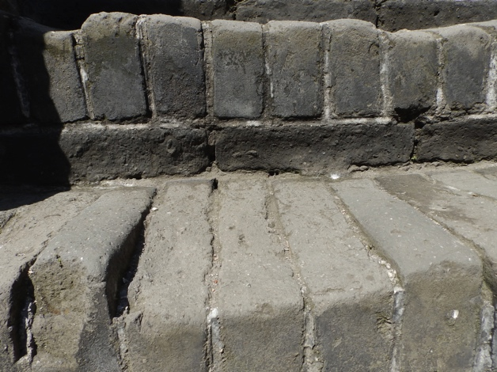

Spearman’s Rank

Correlation Coefficient (Rs)

**What is it?**

This is one of the most widely used statistical tests in Geography. It is relatively quick and easy to do, but is classified as a complex method. It is called a ‘rank’ correlation because only the *ranks* (as opposed to the raw data) are correlated.

**Why do we use it?**

Rsallows us to decide whether or not there is a **correlation** (relationship) between two sets of data. In some cases it is obvious whether a correlation exists, however, in most cases it is not so clear.

It also tests the reliability of this data in relation to your sample size (‘*n’*).

How do we use it?

Spearman’s rank will give us a value from –1 to +1 (if you value falls outside of this range you have made a mistake somewhere). The closer to +1 your Rs value is, the stronger the positive correlation. The closer to –1, the stronger the negative correlation.

We calculate the Spearman’s rank (Rs) using the formula:

Rs = Spearman Rank Formula

A Step-by-step guide

1. Complete the table. Don’t forget, the highest value is ranked 1.
2. Rank the data in Column D. The highest should be awarded 1 and the lowest ranked 15.
3. Calculate the *difference* (‘**d**’) in the two ranks (B-D) and enter the figure in Column E.
4. *Square* the differences listed in Column E and enter the results in Column F (‘**d2**’).
5. Add all the squares together and put the total at the bottom of Column F.
6. You can now calculate the Rs figure and assess the strength of the relationship, by putting the appropriate numbers into the equation. *N* means the number in your sample, in this case 15. Show each stage of working.
7. Then write a conclusion on your result. Is there a relationship? 0 being no correlation, 1 being strong/perfect positive, and -1 being strong/perfect negative.
8. Compare your result with the values in the statistical ‘significance level’ table (Fig 3) to establish the **level** of significance.

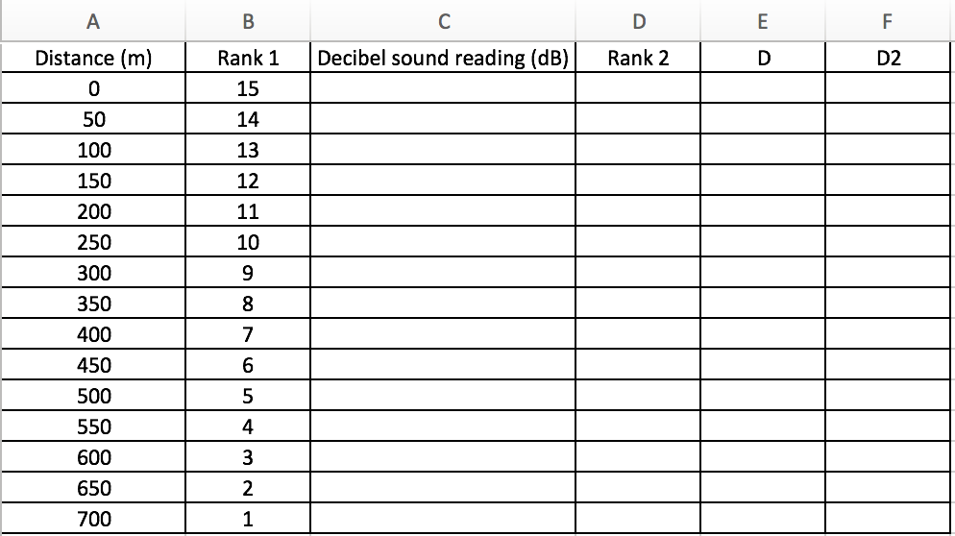

Sum of **d2:**





Step 2:

Step 3:

Step 1:

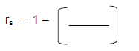

Rs =

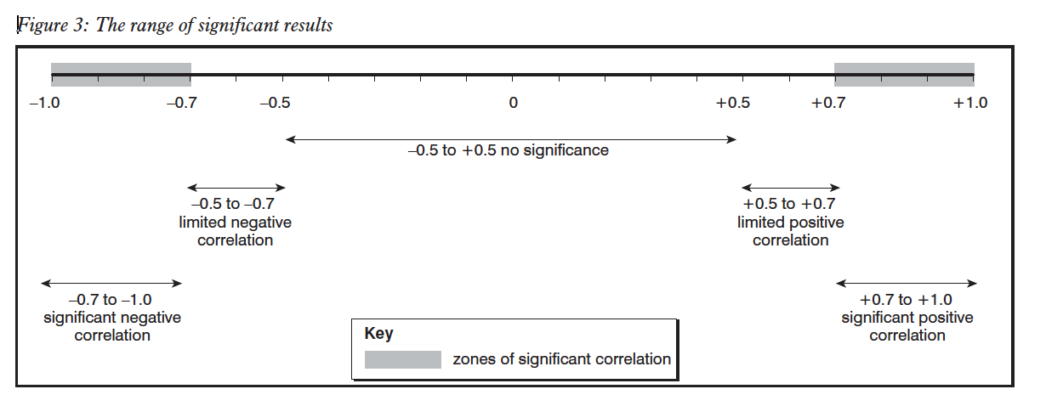

1. M: ___ F: ___ Questionnaire No: 1
2. Age: 0-20: ___ 21-30: ____ 31-40: ___ 41-50: ___ 51-60: ___ 61+ ____
3. Are you a: Visitor _____ Worker _____
4. Where do you live? _______________
5. How long did it take you to travel here today?   
   Less than 1 hour ____ Between 1 and 2 hours _____   
   Between 2 and 3 hours _____ More than 3 hours _____
6. How did you get here?   
   Bus ____ Minibus _____ Car______ Motorbike____  
   Bike ______ Walk ______ Other____________
7. How many times have you visited this area?  
   First time ____ Twice ___ Three times___ Many (4+) ____
8. How would you grade the quality of the environment in this area?

Excellent: _____ Good: ______ OK: ______

Poor: _______ Very Poor (needs improving): _____

1. Would you say that tourism has had a positive or a negative impact on the environmental in this area?   
   Negative impact: ______ Positive impact: ______ Both: _____
2. What environmental impacts of tourism on Mutianyu have you seen?  
   Negative impacts Positive impacts  
   Litter ___ Improved the wall ___  
   Noise Pollution ___ More tree planting ___  
   Traffic Congestion ___ Better management ___  
   Air Pollution ___ Conservation signs ___  
   Deforestation ___ Other ______________  
   Graffiti on wall ___ ___________________  
   Footpath erosion ___ ___________________
3. M: ___ F: ___ Questionnaire No: 2
4. Age: 0-20: ___ 21-30: ____ 31-40: ___ 41-50: ___ 51-60: ___ 61+ ____
5. Are you a: Visitor _____ Worker _____
6. Where do you live? _______________
7. How long did it take you to travel here today?   
   Less than 1 hour ____ Between 1 and 2 hours _____   
   Between 2 and 3 hours _____ More than 3 hours _____
8. How did you get here?   
   Bus ____ Minibus _____ Car______ Motorbike____  
   Bike ______ Walk ______ Other____________
9. How many times have you visited this area?  
   First time ____ Twice ___ Three times___ Many (4+) ____
10. How would you grade the quality of the environment in this area?
    1. Excellent: _____ Good: ______ OK: ______
    2. Poor: _______ Very Poor (needs improving): _____
11. Would you say that tourism has had a positive or a negative impact on the environmental in this area?   
    Negative impact: ______ Positive impact: ______ Both: _____
12. What environmental impacts of tourism on Mutianyu have you seen?  
    Negative impacts Positive impacts  
    Litter ___ Improved the wall ___  
    Noise Pollution ___ More tree planting ___  
    Traffic Congestion ___ Better management ___  
    Air Pollution ___ Conservation signs ___  
    Deforestation ___ Other ______________  
    Graffiti on wall ___ ___________________  
    Footpath erosion ___ ___________________
13. M: ___ F: ___ Questionnaire No: 3
14. Age: 0-20: ___ 21-30: ____ 31-40: ___ 41-50: ___ 51-60: ___ 61+ ____
15. Are you a: Visitor _____ Worker _____
16. Where do you live? _______________
17. How long did it take you to travel here today?   
    Less than 1 hour ____ Between 1 and 2 hours _____   
    Between 2 and 3 hours _____ More than 3 hours _____
18. How did you get here?   
    Bus ____ Minibus _____ Car______ Motorbike____  
    Bike ______ Walk ______ Other____________
19. How many times have you visited this area?  
    First time ____ Twice ___ Three times___ Many (4+) ____
20. How would you grade the quality of the environment in this area?
    1. Excellent: _____ Good: ______ OK: ______
    2. Poor: _______ Very Poor (needs improving): _____
21. Would you say that tourism has had a positive or a negative impact on the environmental in this area?   
    Negative impact: ______ Positive impact: ______ Both: _____
22. What environmental impacts of tourism on Mutianyu have you seen?  
    Negative impacts Positive impacts  
    Litter ___ Improved the wall ___  
    Noise Pollution ___ More tree planting ___  
    Traffic Congestion ___ Better management ___  
    Air Pollution ___ Conservation signs ___  
    Deforestation ___ Other ______________  
    Graffiti on wall ___ ___________________  
    Footpath erosion ___ ___________________
23. M: ___ F: ___ Questionnaire No: 4
24. Age: 0-20: ___ 21-30: ____ 31-40: ___ 41-50: ___ 51-60: ___ 61+ ____
25. Are you a: Visitor _____ Worker _____
26. Where do you live? _______________
27. How long did it take you to travel here today?   
    Less than 1 hour ____ Between 1 and 2 hours _____   
    Between 2 and 3 hours _____ More than 3 hours _____
28. How did you get here?   
    Bus ____ Minibus _____ Car______ Motorbike____  
    Bike ______ Walk ______ Other____________
29. How many times have you visited this area?  
    First time ____ Twice ___ Three times___ Many (4+) ____
30. How would you grade the quality of the environment in this area?
    1. Excellent: _____ Good: ______ OK: ______
    2. Poor: _______ Very Poor (needs improving): _____
31. Would you say that tourism has had a positive or a negative impact on the environmental in this area?   
    Negative impact: ______ Positive impact: ______ Both: _____
32. What environmental impacts of tourism on Mutianyu have you seen?  
    Negative impacts Positive impacts  
    Litter ___ Improved the wall ___  
    Noise Pollution ___ More tree planting ___  
    Traffic Congestion ___ Better management ___  
    Air Pollution ___ Conservation signs ___  
    Deforestation ___ Other ______________  
    Graffiti on wall ___ ___________________  
    Footpath erosion ___ ___________________
33. M: ___ F: ___ Questionnaire No: 5
34. Age: 0-20: ___ 21-30: ____ 31-40: ___ 41-50: ___ 51-60: ___ 61+ ____
35. Are you a: Visitor _____ Worker _____
36. Where do you live? _______________
37. How long did it take you to travel here today?   
    Less than 1 hour ____ Between 1 and 2 hours _____   
    Between 2 and 3 hours _____ More than 3 hours _____
38. How did you get here?   
    Bus ____ Minibus _____ Car______ Motorbike____  
    Bike ______ Walk ______ Other____________
39. How many times have you visited this area?  
    First time ____ Twice ___ Three times___ Many (4+) ____
40. How would you grade the quality of the environment in this area?
    1. Excellent: _____ Good: ______ OK: ______
    2. Poor: _______ Very Poor (needs improving): _____
41. Would you say that tourism has had a positive or a negative impact on the environmental in this area?   
    Negative impact: ______ Positive impact: ______ Both: _____
42. What environmental impacts of tourism on Mutianyu have you seen?  
    Negative impacts Positive impacts  
    Litter ___ Improved the wall ___  
    Noise Pollution ___ More tree planting ___  
    Traffic Congestion ___ Better management ___  
    Air Pollution ___ Conservation signs ___  
    Deforestation ___ Other ______________  
    Graffiti on wall ___ ___________________  
    Footpath erosion ___ ___________________

Field Sketch (fully annotated)

Site: 2

Field Sketch (fully annotated)

Site: 3