Our Coasts
The area where the sea and land meet is called a coast. The coasts of the world measure about 193,000 miles (312,000 kilometers) in total. Coastal areas are also known as shores and seasides. They form unique habitats where a range of animals and plants survive in a challenging environment.
The coast is divided into 4 different areas (complete the boxes in the diagram below)
- Offshore
- Backshore
- Nearshore
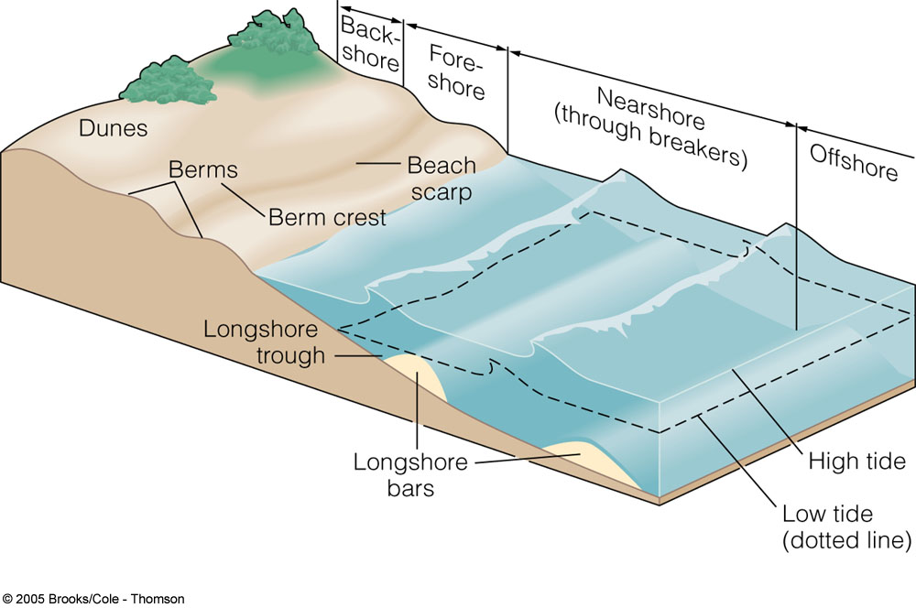
- Foreshore

