South China Sea dispute
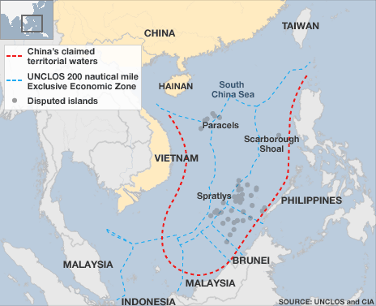
What is the argument about?
- dispute over territory + sovereignty over ocean areas
- dispute for two island chains (Paracels and the Spratlys)
Who claims what?
- China: the largest portion of territory: "nine-dash line" =stretches hundreds of miles south+ east from of Hainan (southern china). Beijing has said its right to the area come from 2,000 years ago where the Paracel + Spratly island chains= integral parts of the Chinese nation.
- The island considers itself the Republic of China and has the same territorial claims
- Vietnam: says China had never claimed sovereignty over the islands before the 1940’s= both island chains are entirely within Vietnam territory + has actively ruled over both island chains since the 17th Century.
- The Philippines: uses its geographical proximity to the Spratly Islands as the main basis of its claim
- Malaysia and Brunei: claim to territory in the South China Sea that they say falls within their economic exclusion zones, as defined by UNCLOS. Brunei= no claims vs. Malaysia= claims a small part of the Spratlys.
Why are so many countries so keen? Natural Ressources
- has been little detailed exploration of the area= estimates are largely based upon mineral wealth of neighbouring areas.
- One Chinese estimate: oil reserves of 213 billion barrels vs American scientists estimated 28 billion barrels.
- According to the EIA= real wealth of the area may well be natural gas reserves equal to those of Quatar
- One the region's main shipping lanes+ home to a fishing ground that supplies the livelihoods of thousands of people.

How much trouble does the dispute cause?
- 1974: Chinese seized the Paracels from Vietnam = killed more than 70 Vietnamese troops.
- 1988: the two sides clashed in the Spratlys= Vietnam lost.
- The Philippines has also been involved in a number of minor conflicts with Chinese, Vietnamese and Malaysian forces.
- Recent muscular posturing from China: Beijing officials issued a number of statements (eg: warning their rivals to stop any mineral exploration in the area).
- The Philippines has accused China of building up its military presence in the Spratlys= 2012, the two countries engaged in a maritime stand-off= Chinese and Philippine vessels refused to leave the area for a number of weeks= rhetoric and protests.
- 2012= patrol police in Hainan (China) can board and search foreign ships stopping in its waters or violating other regulations.
- China insists the dispute should be resolved through direct negotiation.
Solutions?
- Over the years, China has tended to favour arrangements negotiated behind closed doors with the individual leaders of other countries. But the other countries have pushed for international mediation.
- Agreements such as the UN's 1982 convention appeared to lay the framework for a solution. But the convention led to more overlapping claims+ did nothing to deter China and Vietnam in pressing their historical claims.
- The regional grouping Asean - whose membership includes all of the main players in the dispute except China and Taiwan - concluded a code of conduct deal with China in 2002.
- Under the agreement, the countries agreed to "resolve their territorial and jurisdictional disputes by peaceful means, without resorting to the threat or use of force, through friendly consultations and negotiations"= recent events suggest that Vietnam and China at least have failed to stick to the spirit of that agreement

