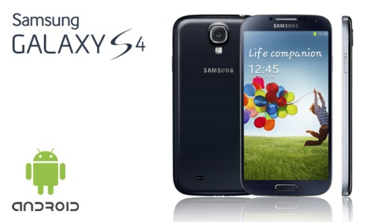
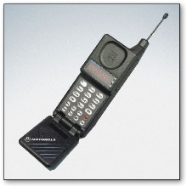
The mobile phone industry over the years

Made notes on how the mobile phone industry has changed – specific focus on Africa. Why is it important for Africa?
The changing mobile phone | Its importance to Africa
