IB DP Geography - Classification of Mass Movement
Type | Examples | Clear diagram to show process | Find out about….
 |  | 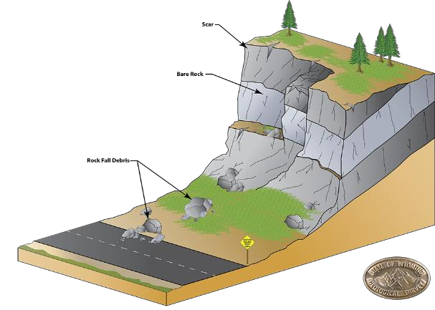 | Liquidity
Landslide (dry) / Rockfall |  |  | Speed of onset  Duration
 |  |  | Extent
 |  |  | Frequency
 |  | 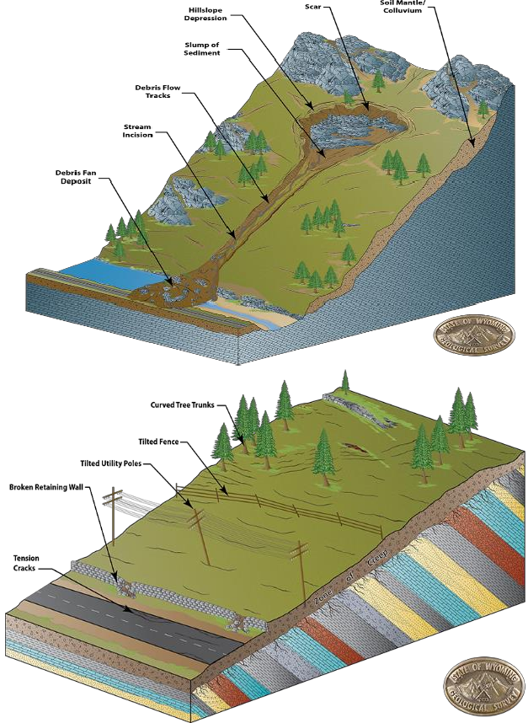 | Liquidity
Mudflow (wet) |  |  | Speed of onset
 |  |  | Duration
 |  |  | Extent
 |  |  | Frequency
Soil Creep |  |  | Liquidity  Speed of onset  Duration  Extent  Frequency
Slumping |  | 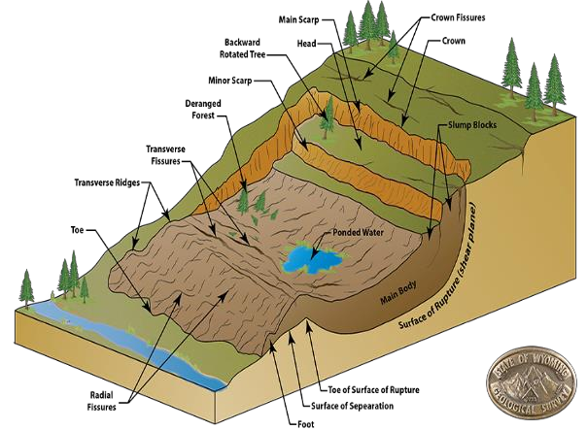 | Liquidity  Speed of onset  Duration  Extent  Frequency

jkjh

